**LAPORAN FINAL PROJECT UJIAN AKHIR**

**SEMESTER 3**



Disusun Oleh **:**

**MUHAMMAD ABDUL RAAFI (21.11.3867)**

**AHMAD MABRURI (21.11.3872)**

1. **Setup**
2. 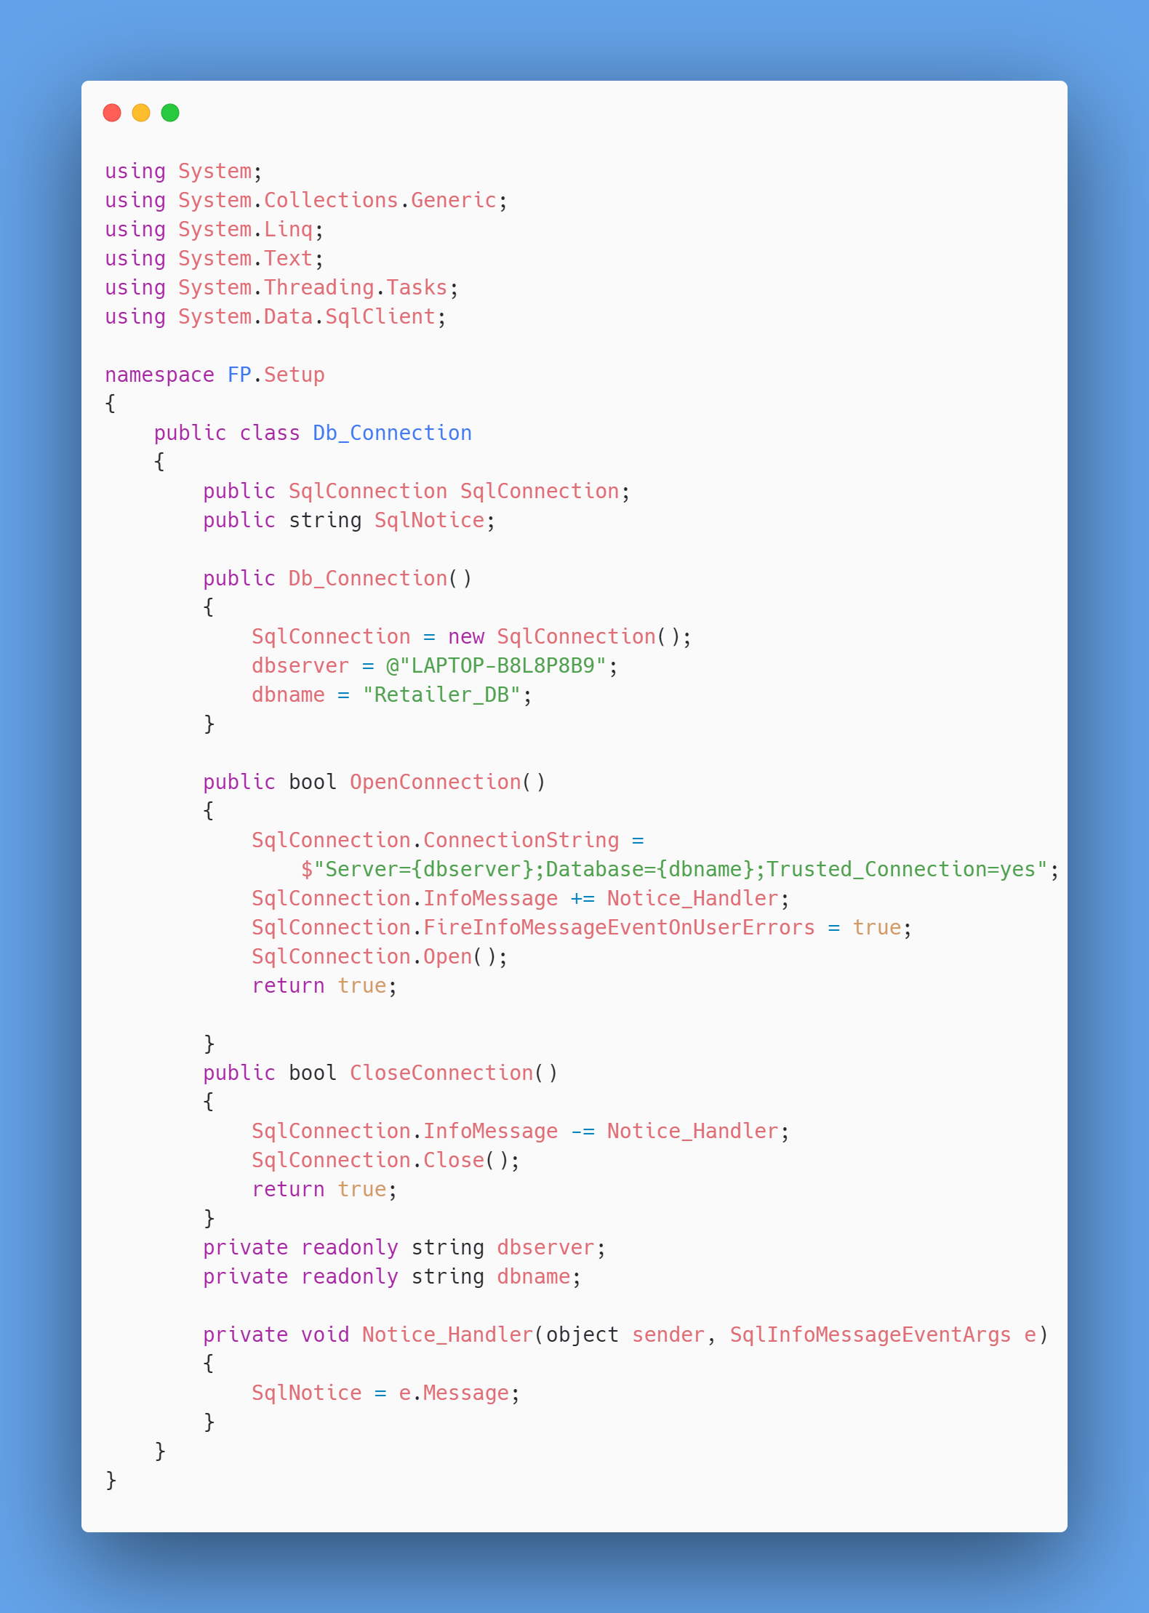Db_Connection
3. 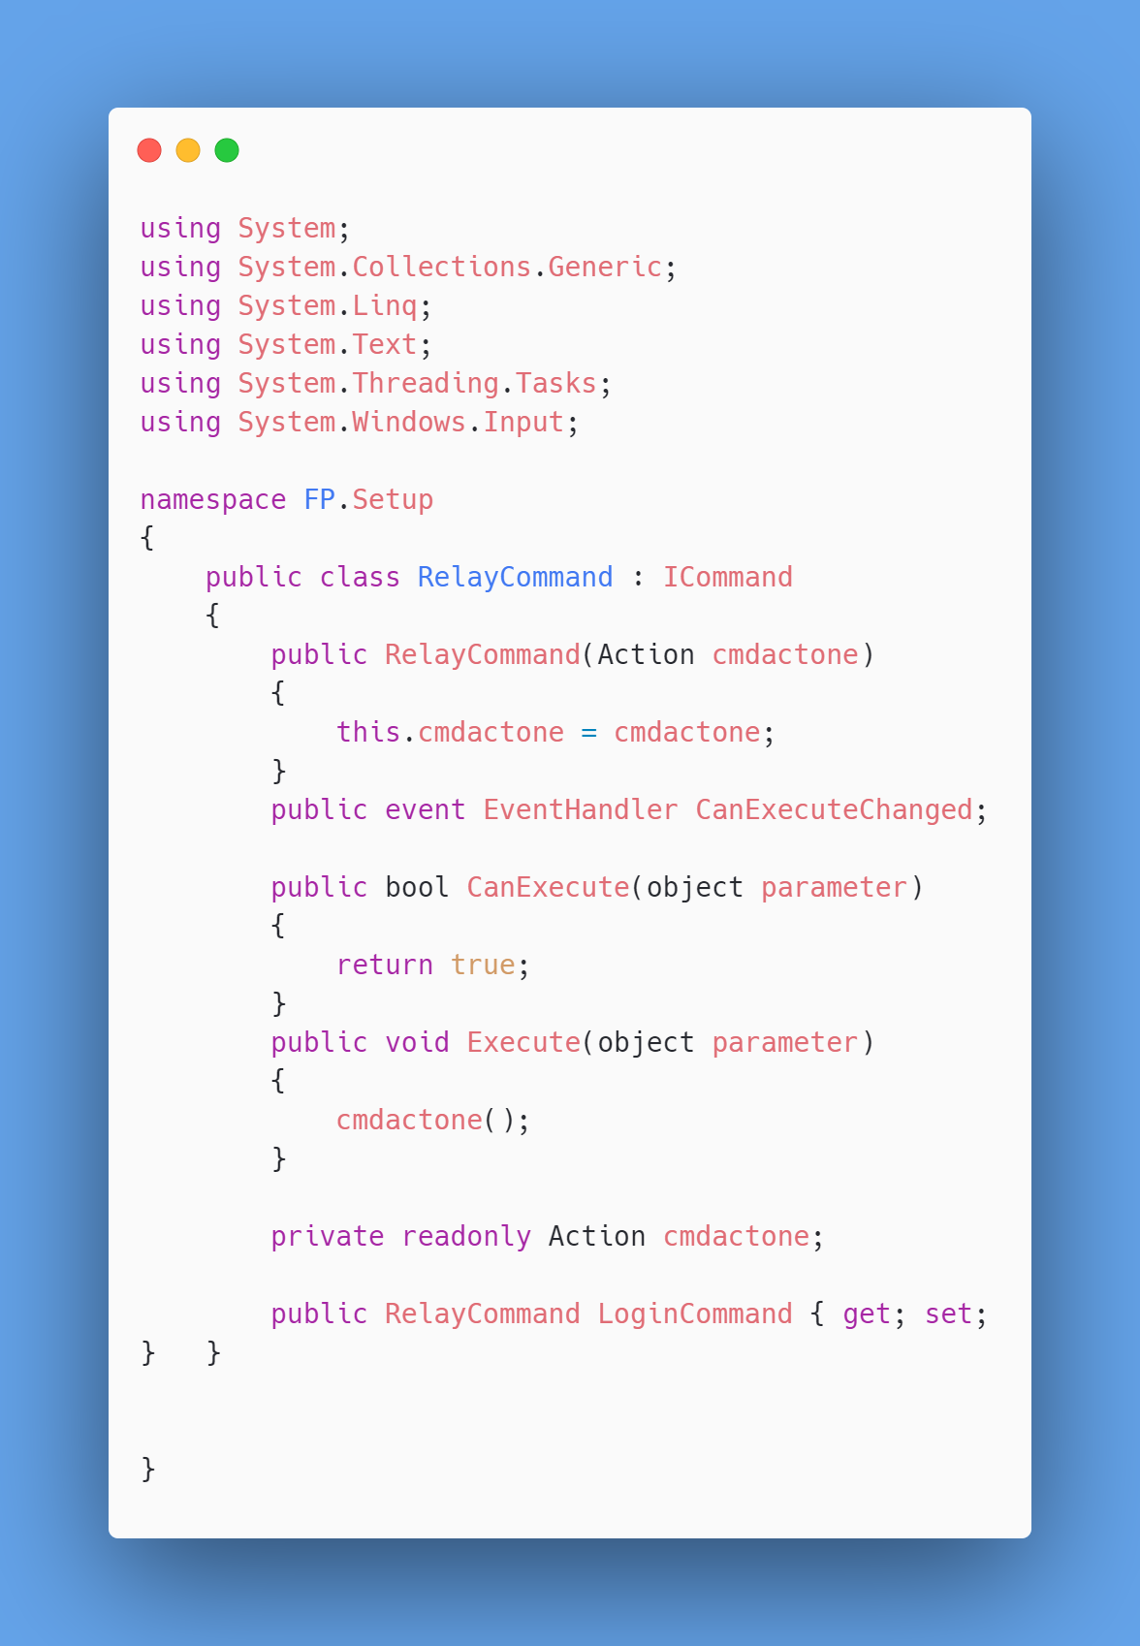RelayCommand
4. **Models**
5. Inventory.cs

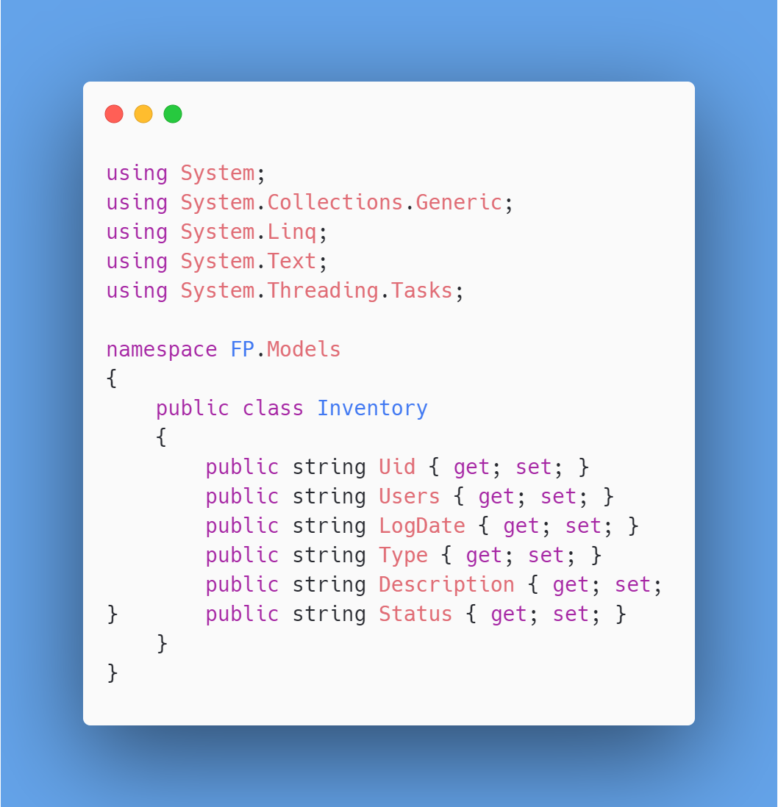

1. InventoryLog.cs

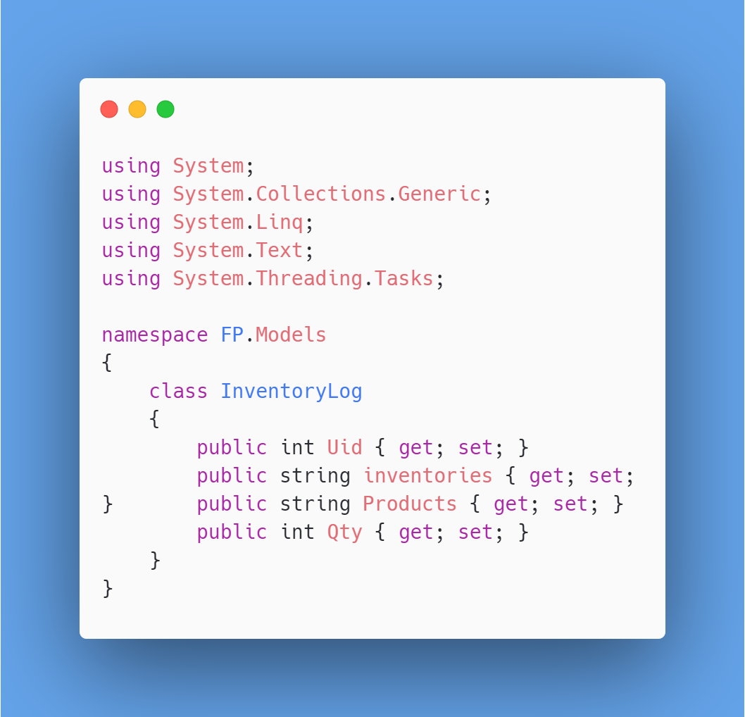

1. Product.cs

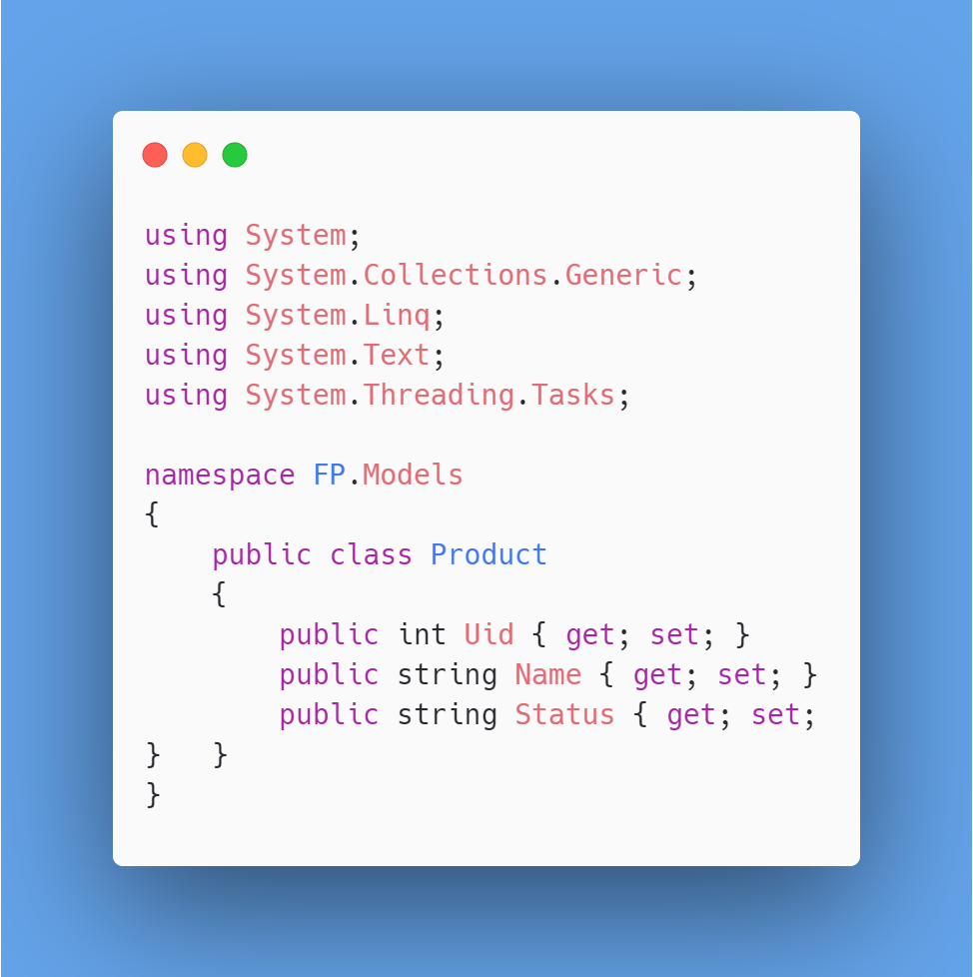

1. User.cs

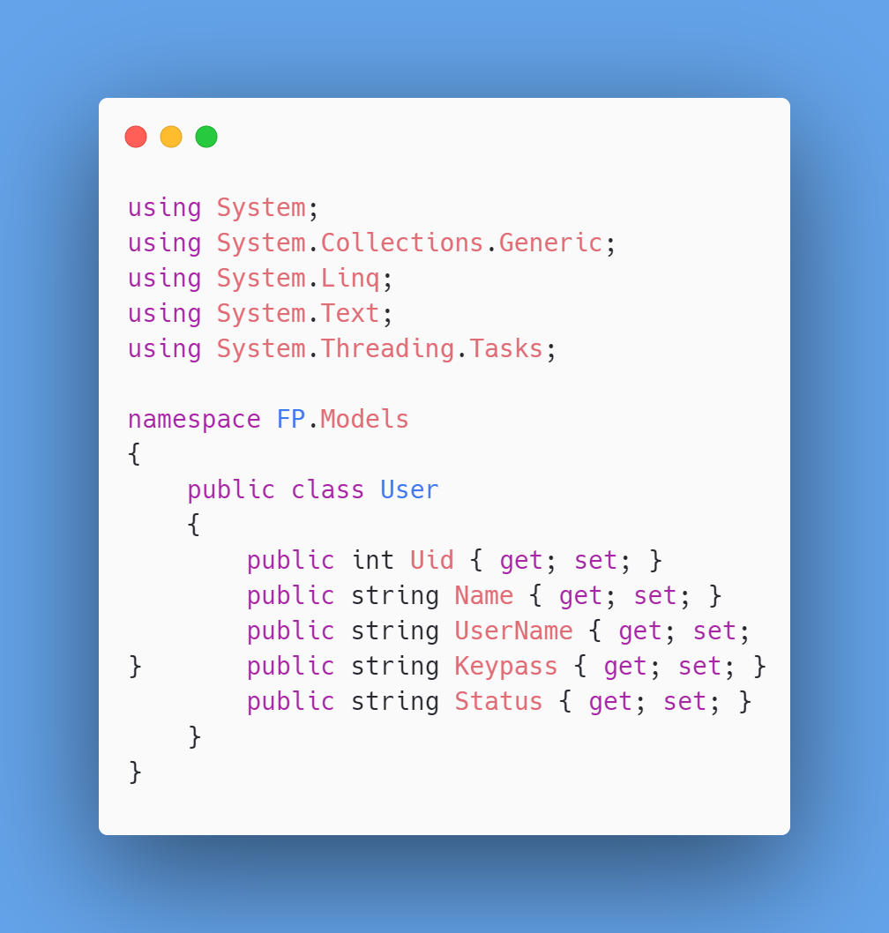

1. UserRule.cs

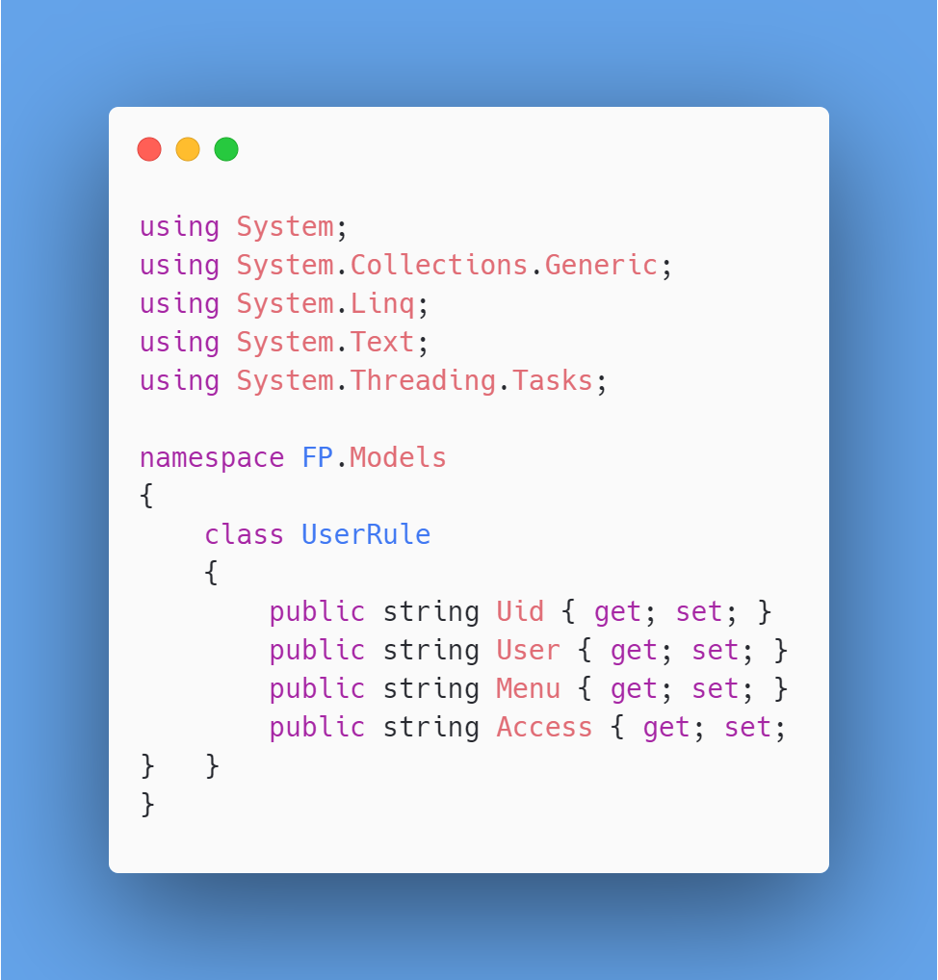

1. **ViewModel**
2. InventoryLogView.cs

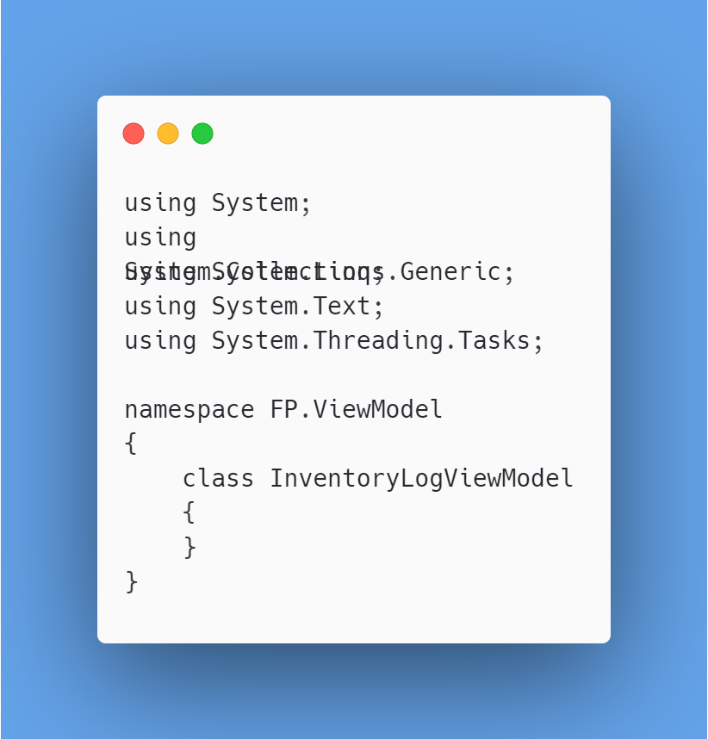

1. InventoryViewModel.cs

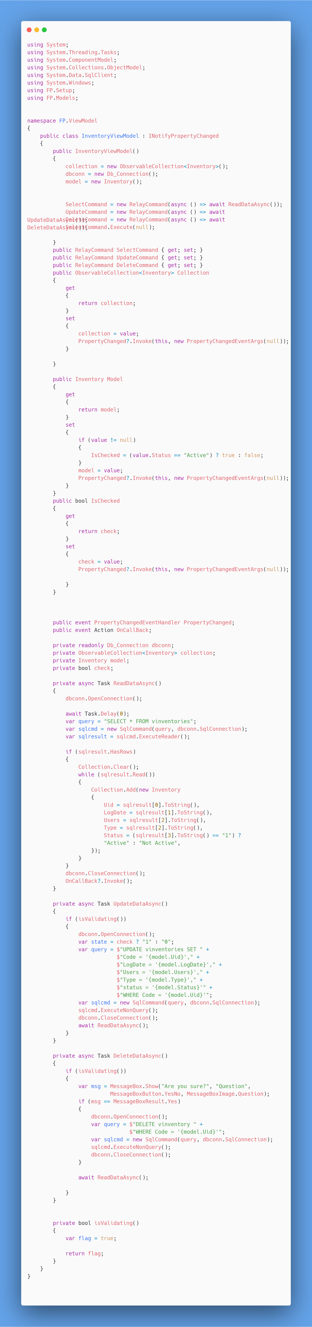





1. ProductViewModel.cs

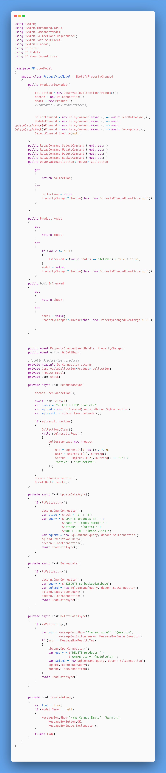





1. UserRuleViewModel.cs

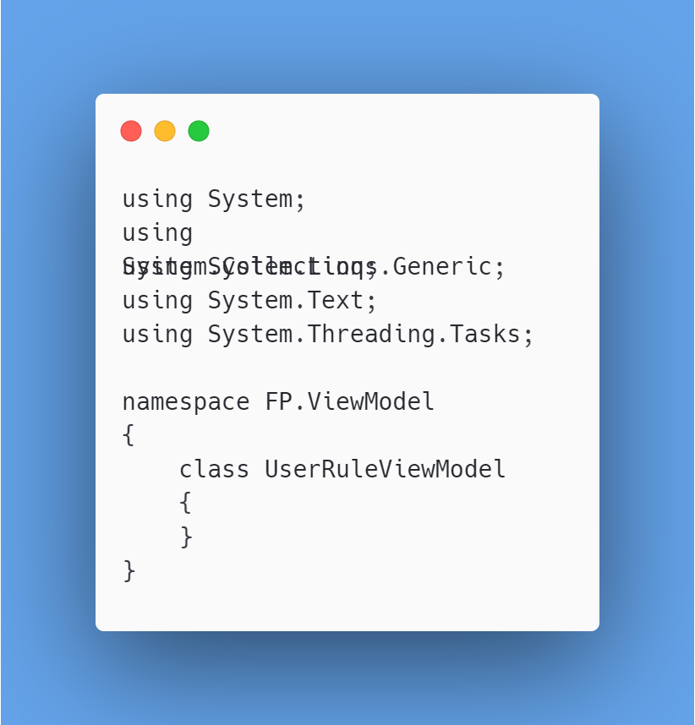

1. UserViewModel.cs

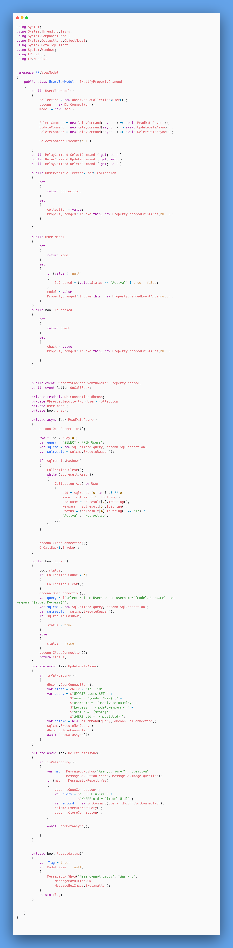





1. **View**

* **Home**

1. Dashboard.xaml

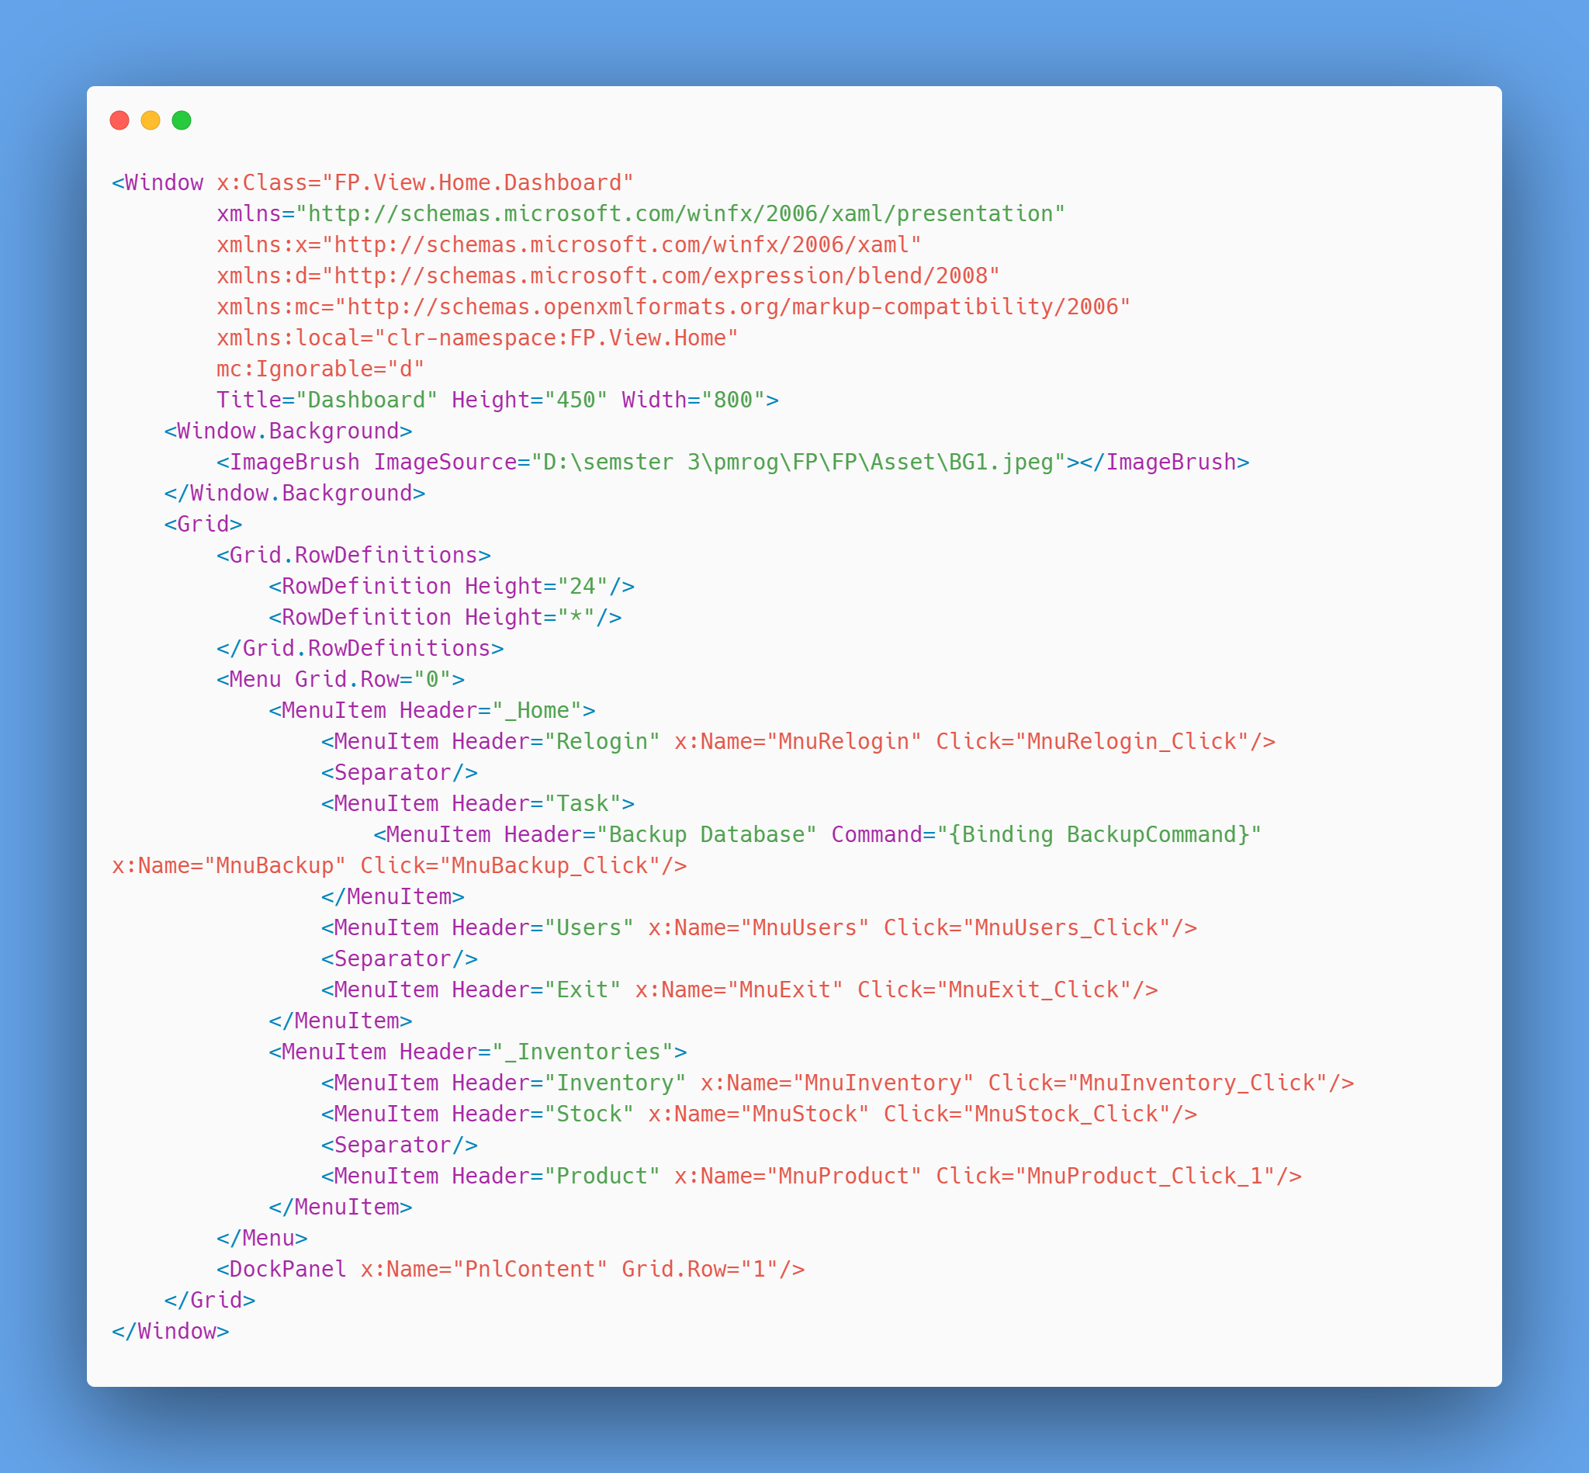

* Dashboard.xaml.cs

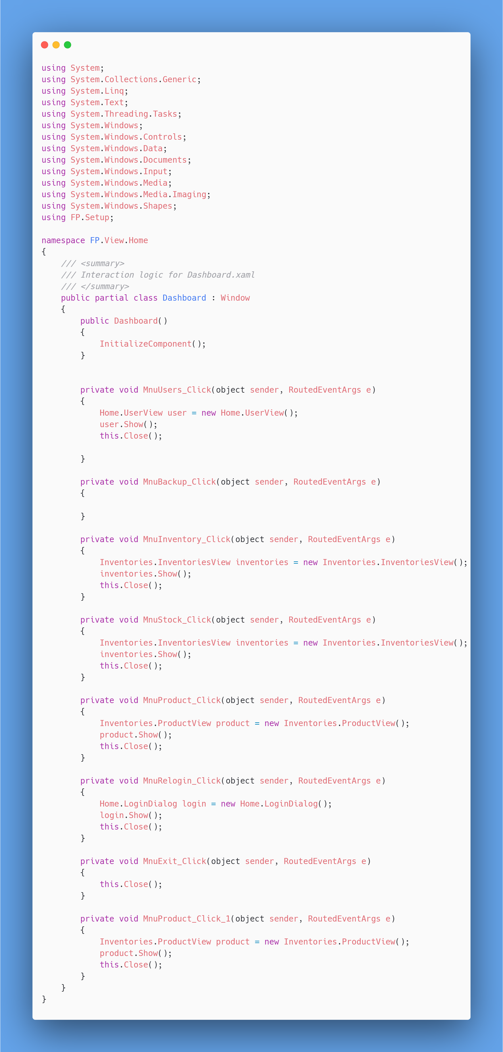



1. LoginDialog.xaml

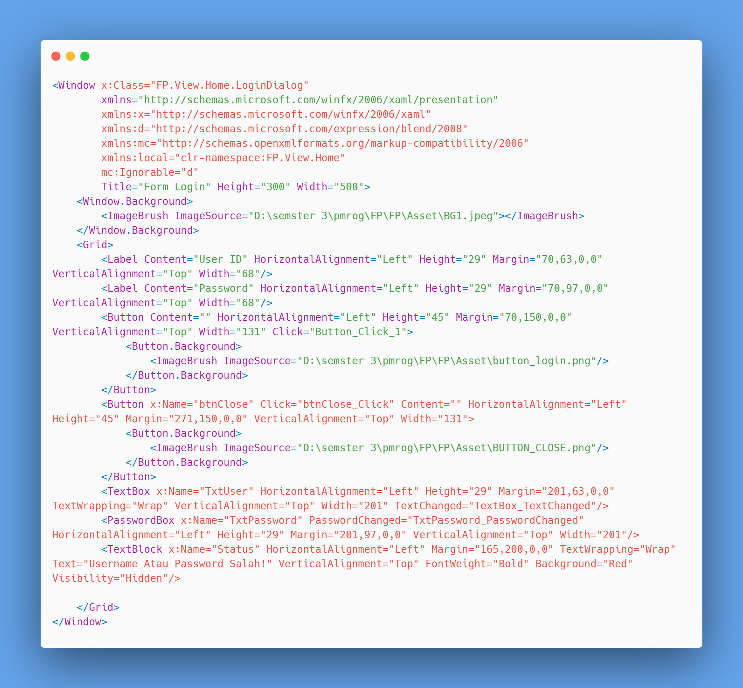

* LoginDialog.xaml.cs

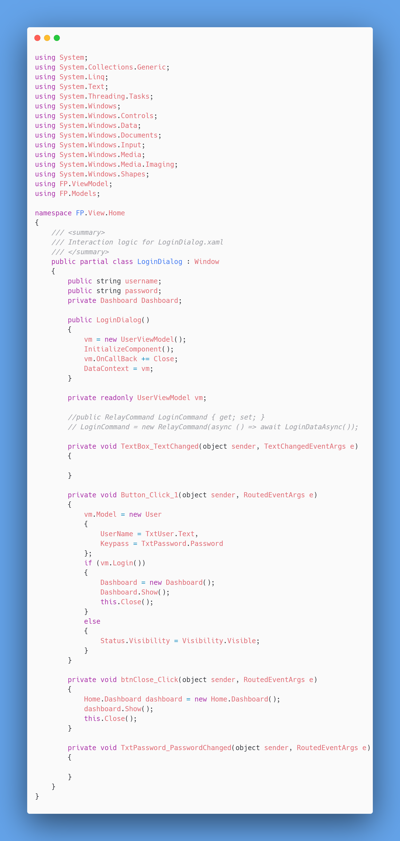



1. RulesDialog.xaml

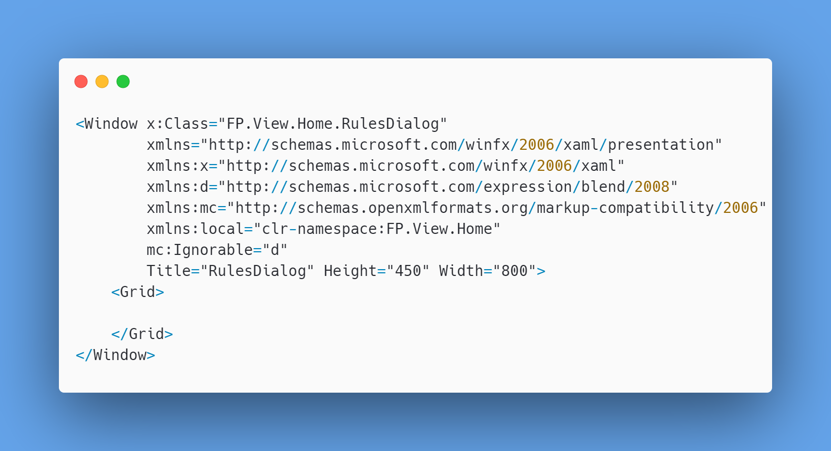

* 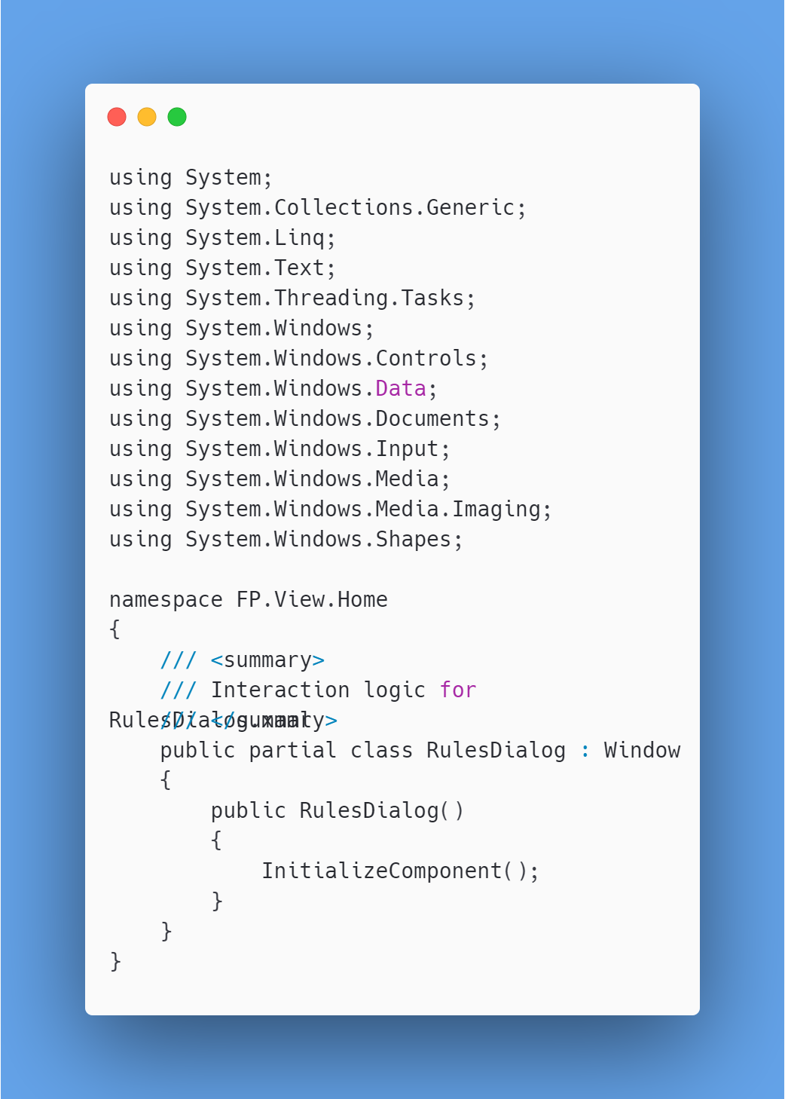RulesDialog.xaml.cs

1. UserView.xaml

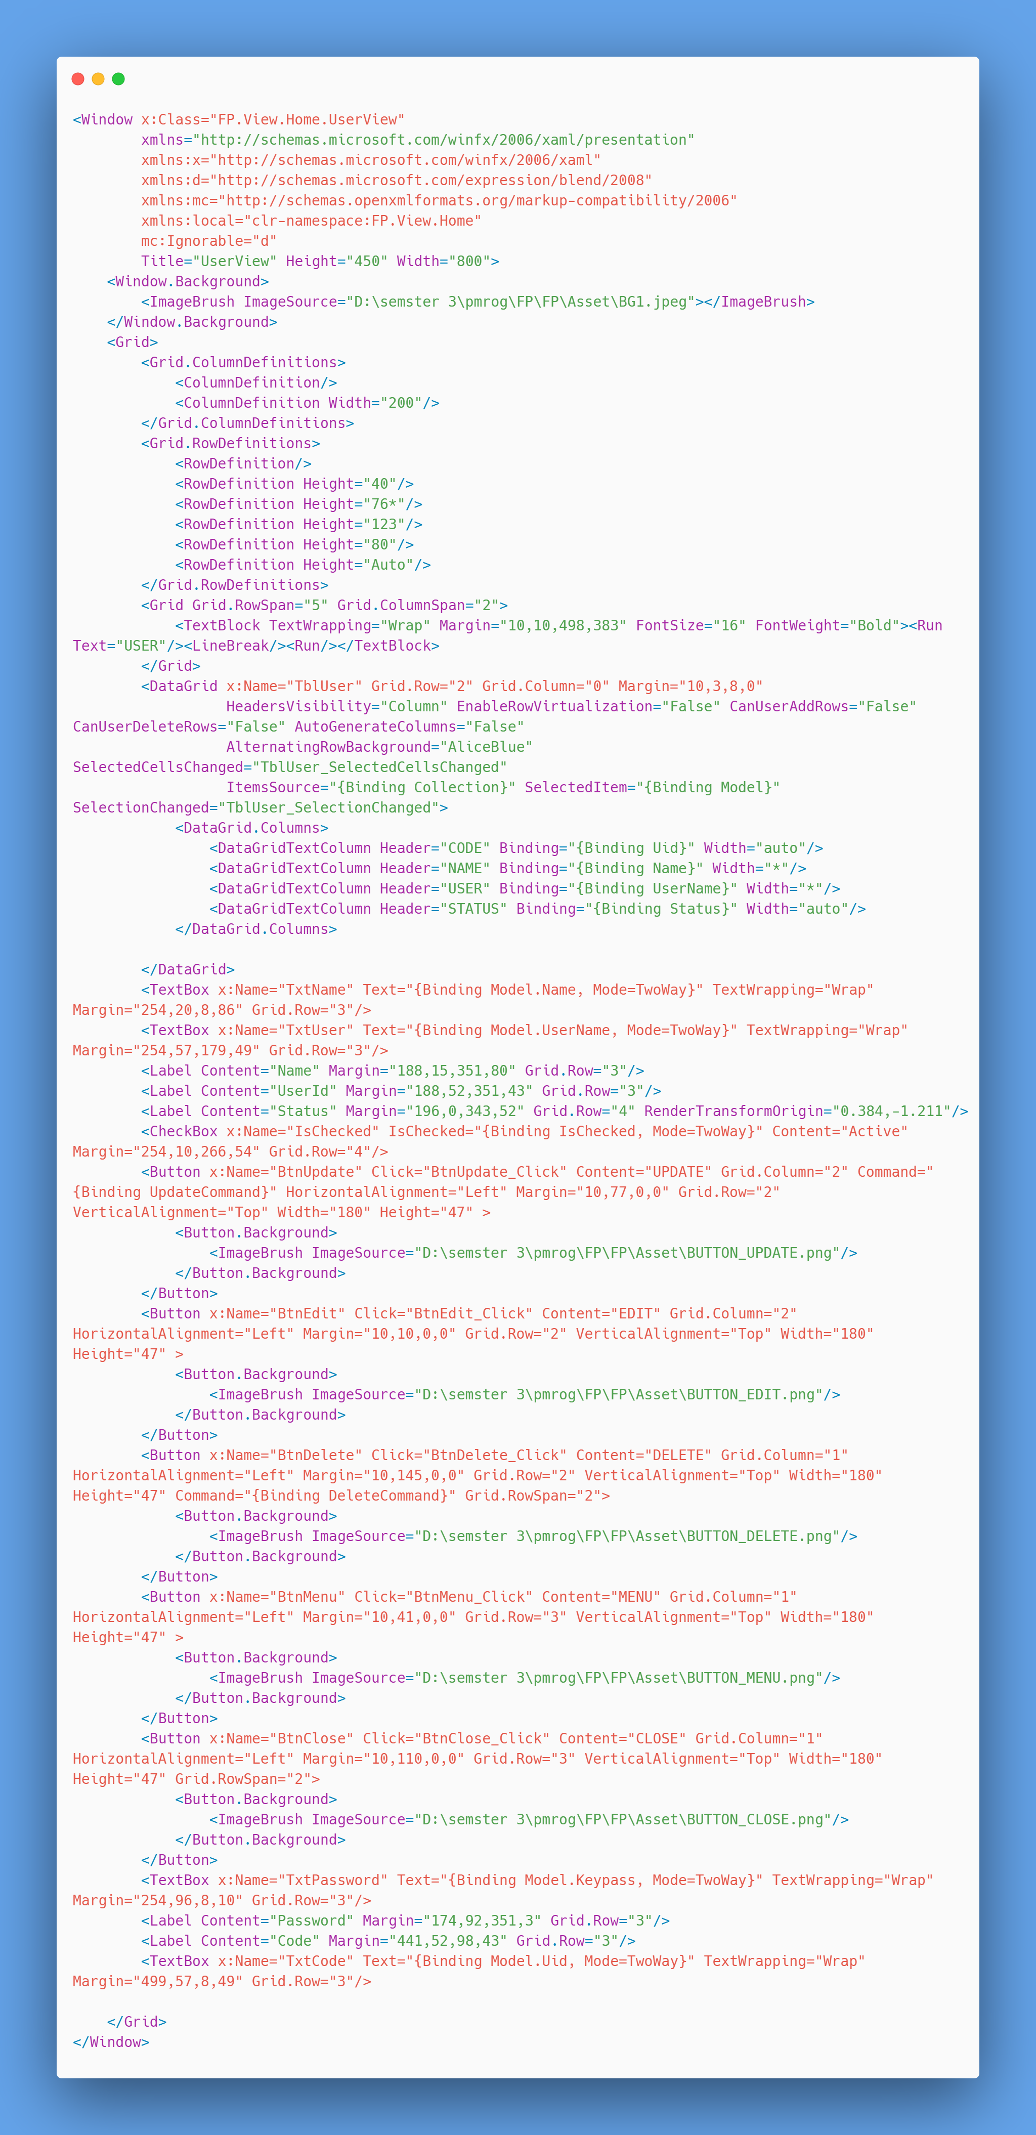



* UserView.xaml.cs

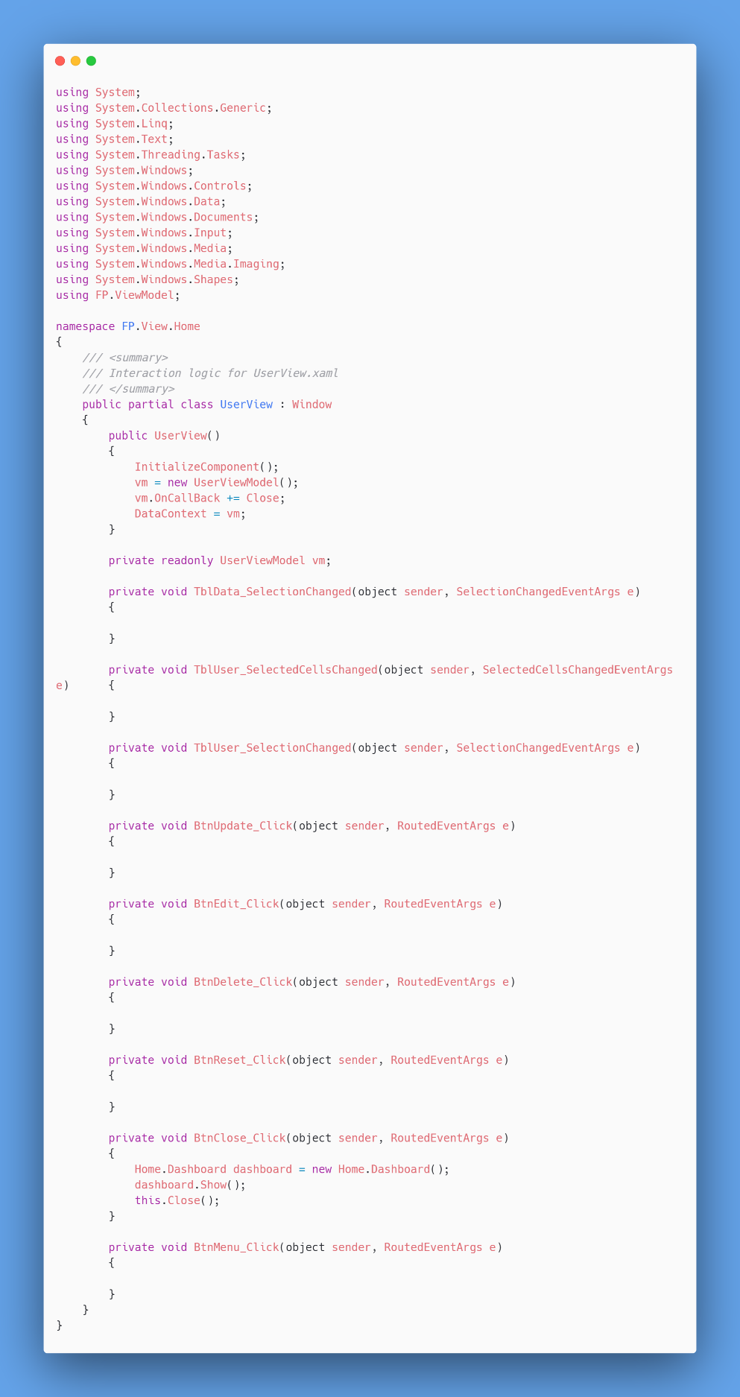

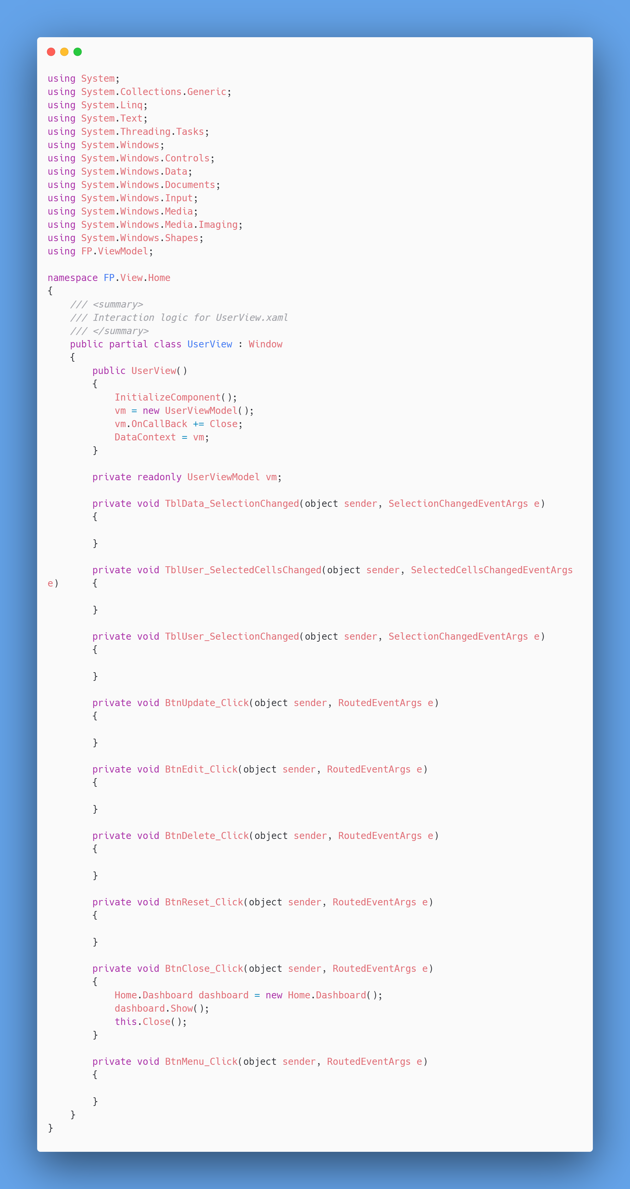

* **Inventories**

1. EditorView.xaml

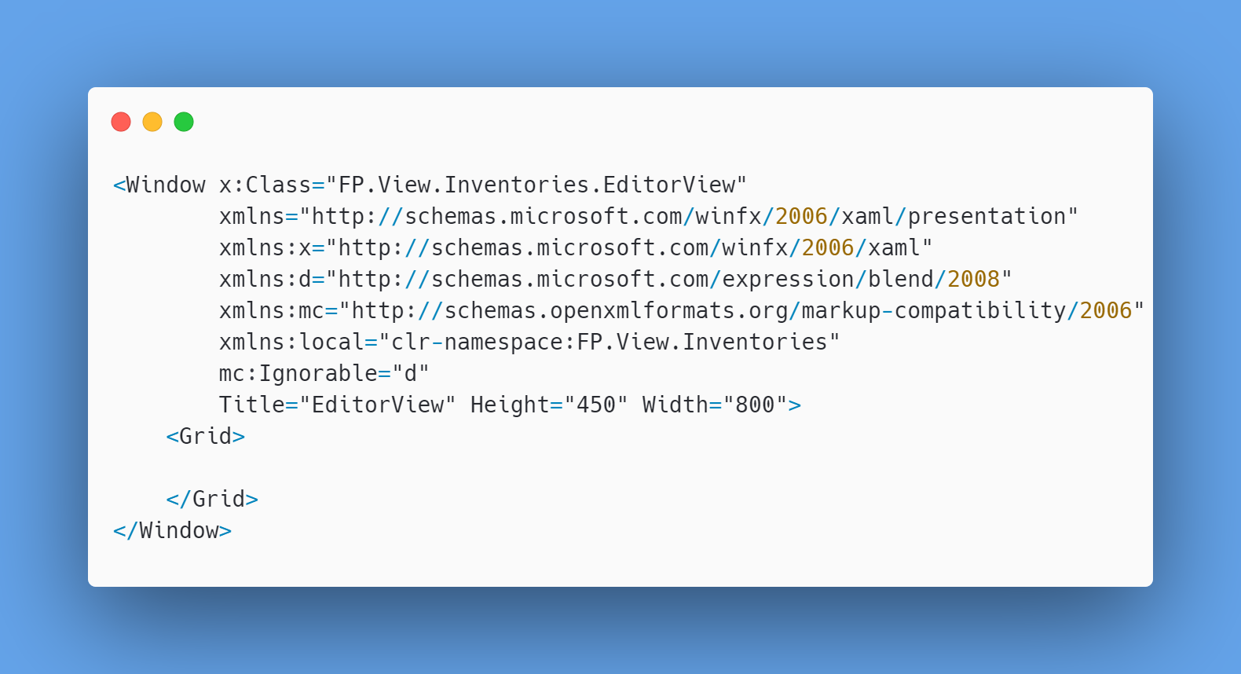

* EditorView.xaml.cs

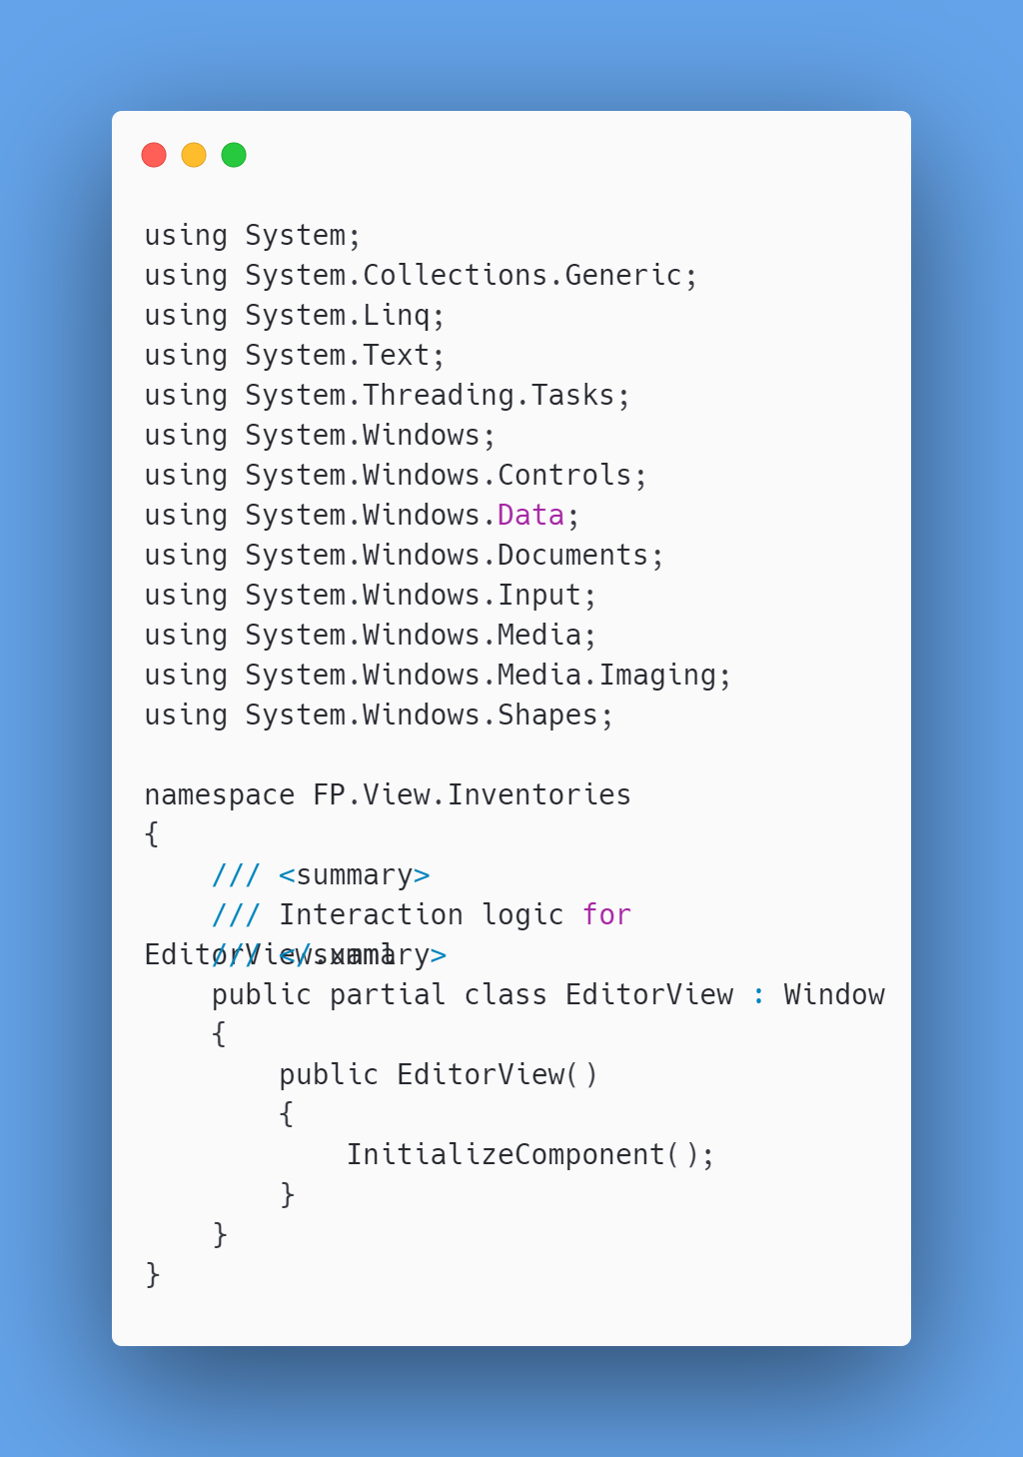



1. InventoriesView.xaml

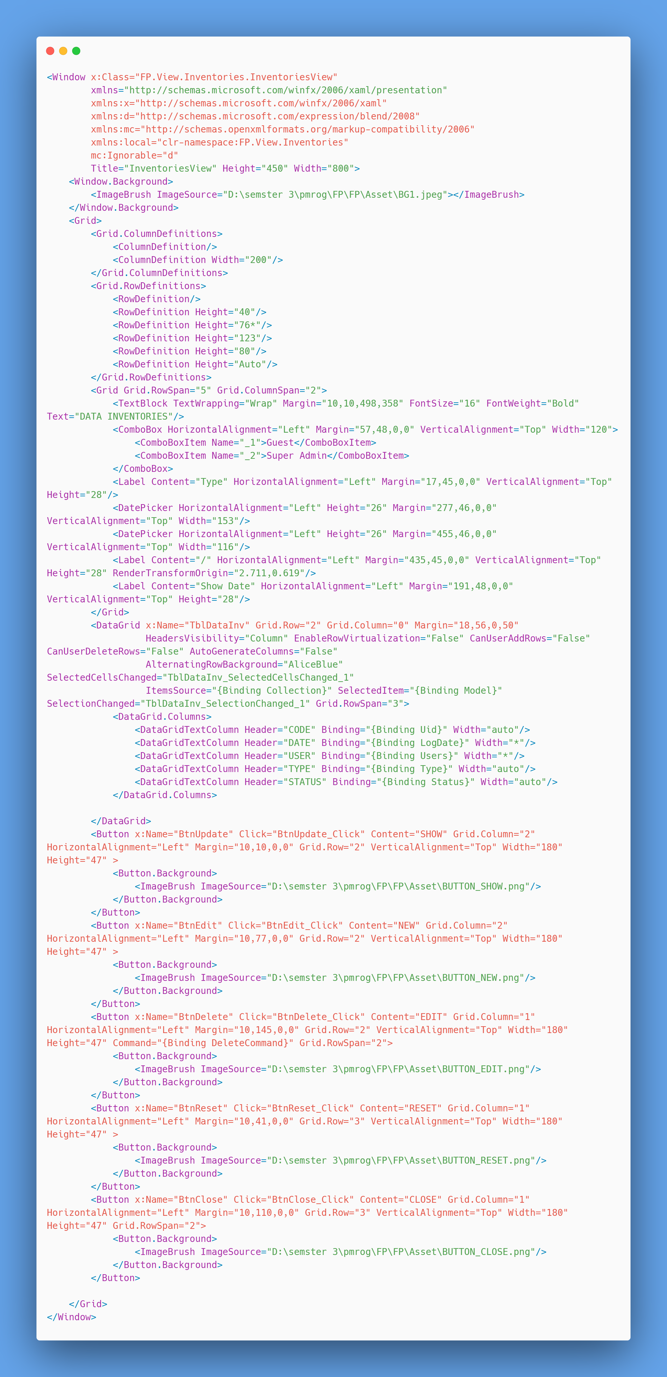



* InventoriesView.xaml.cs

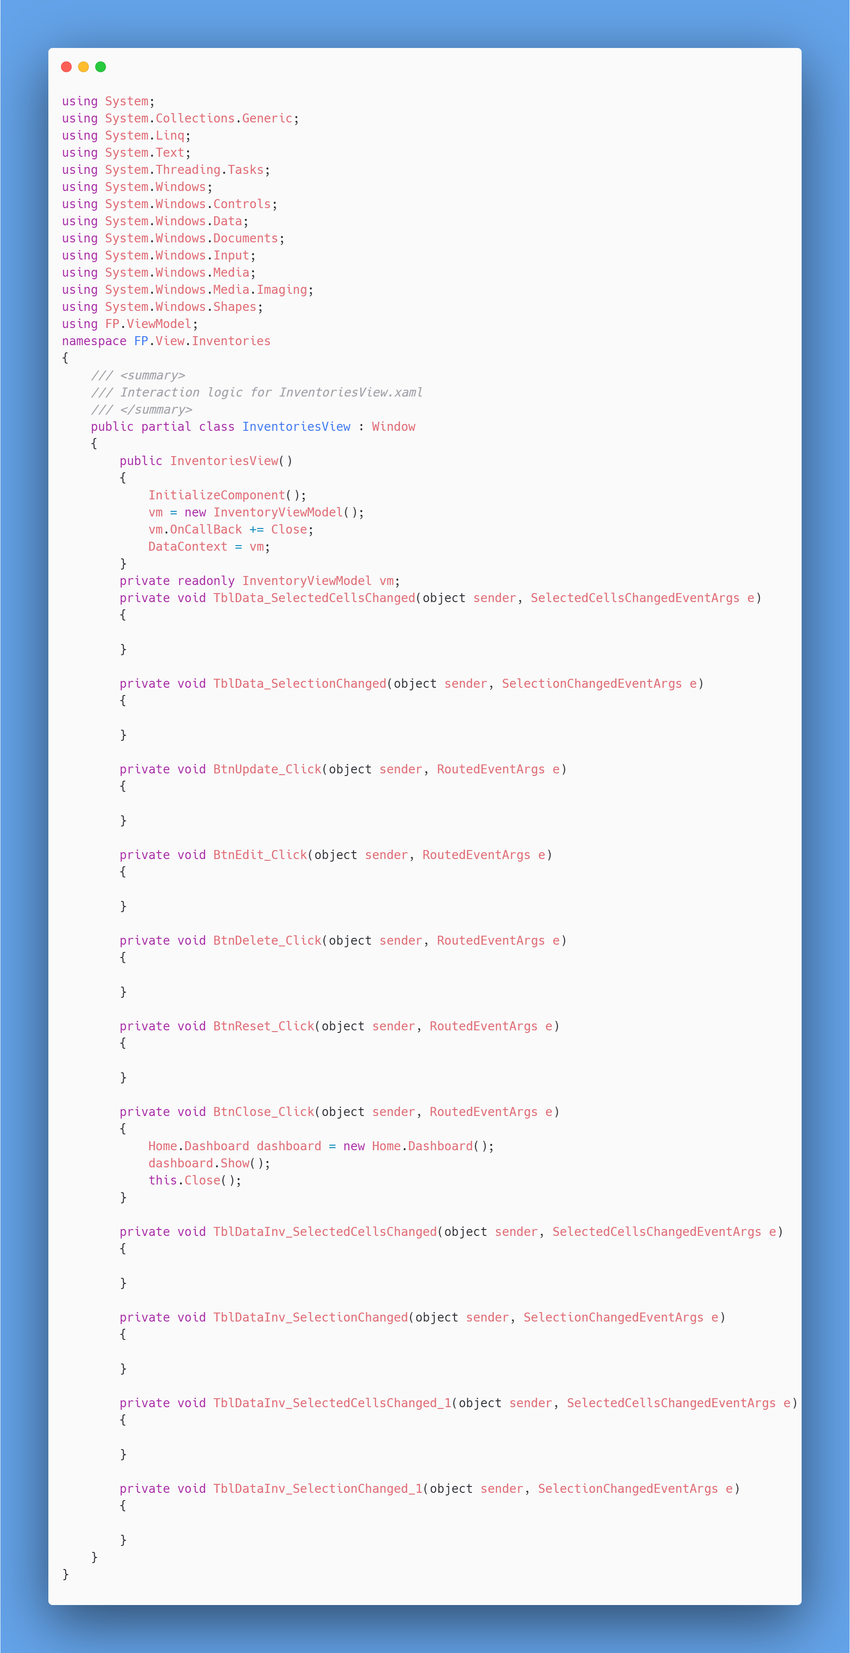



1. ProductView.xaml

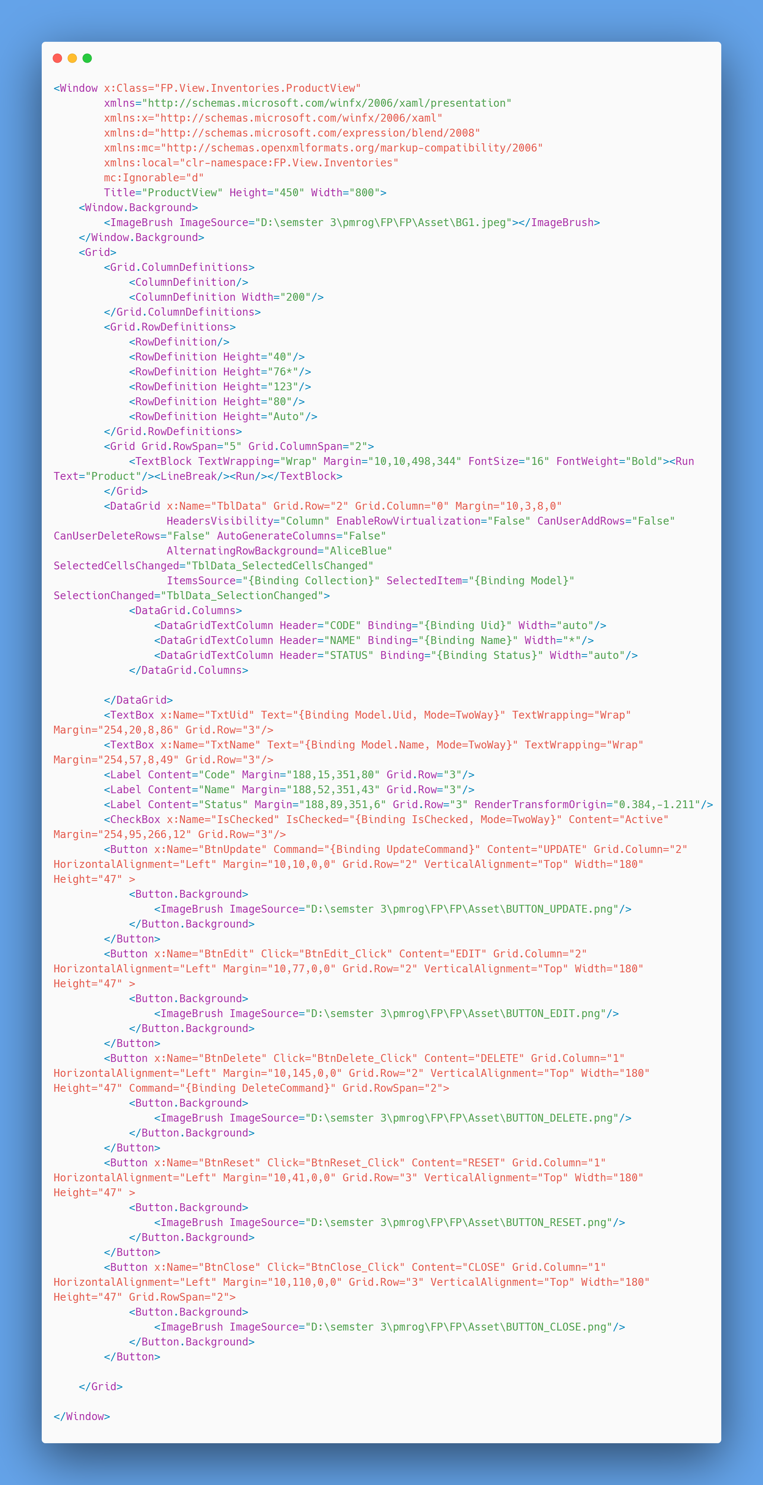



* ProductView.xaml.cs

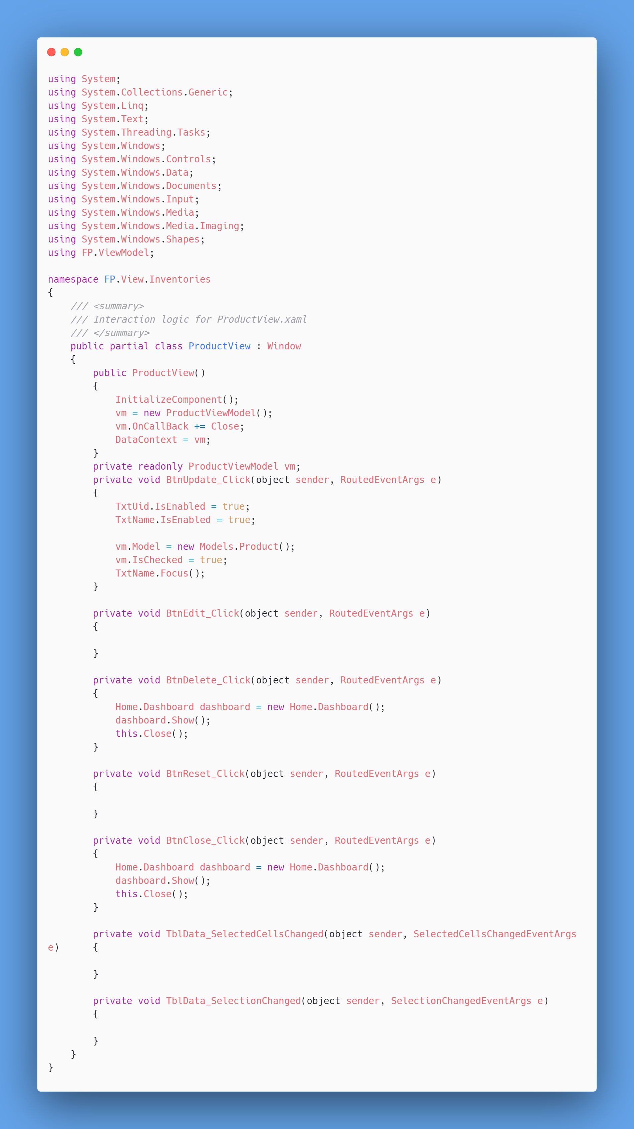



1. StockDialog.xaml

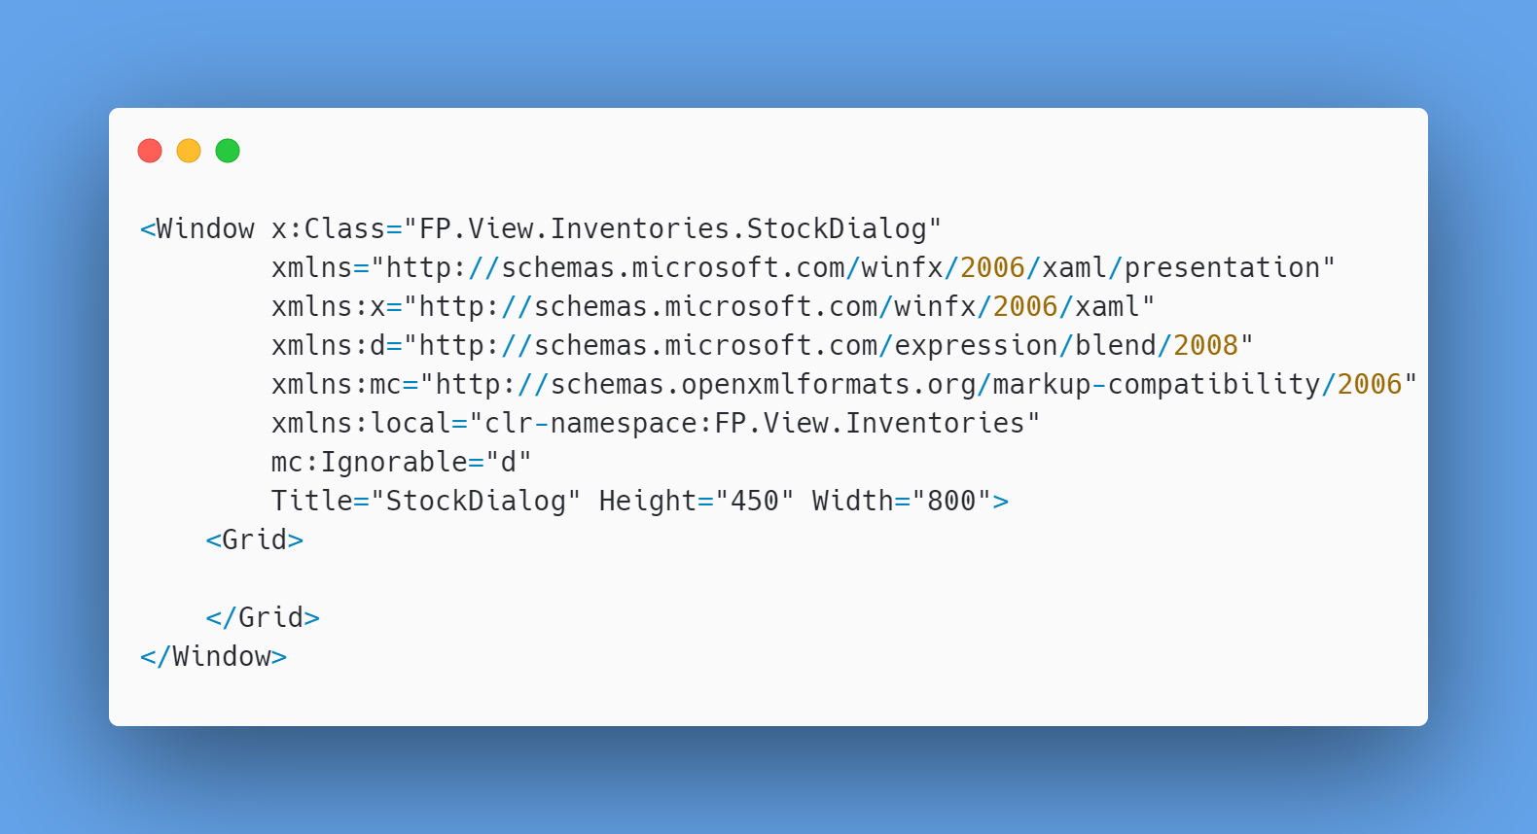

* StockDialog.xaml.cs

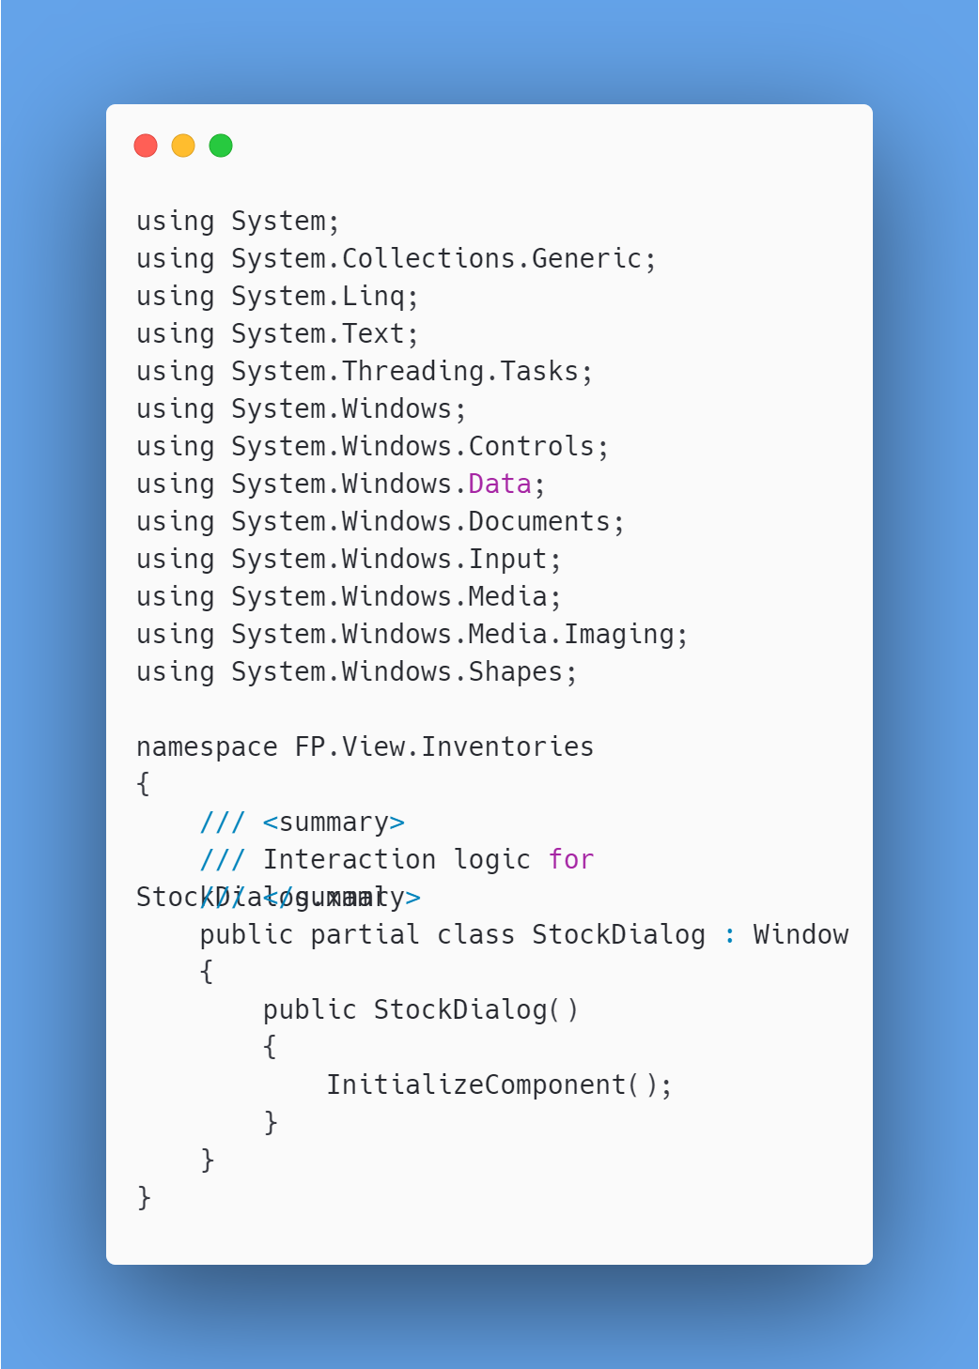



1. **Welcome**
2. Welcome.xaml

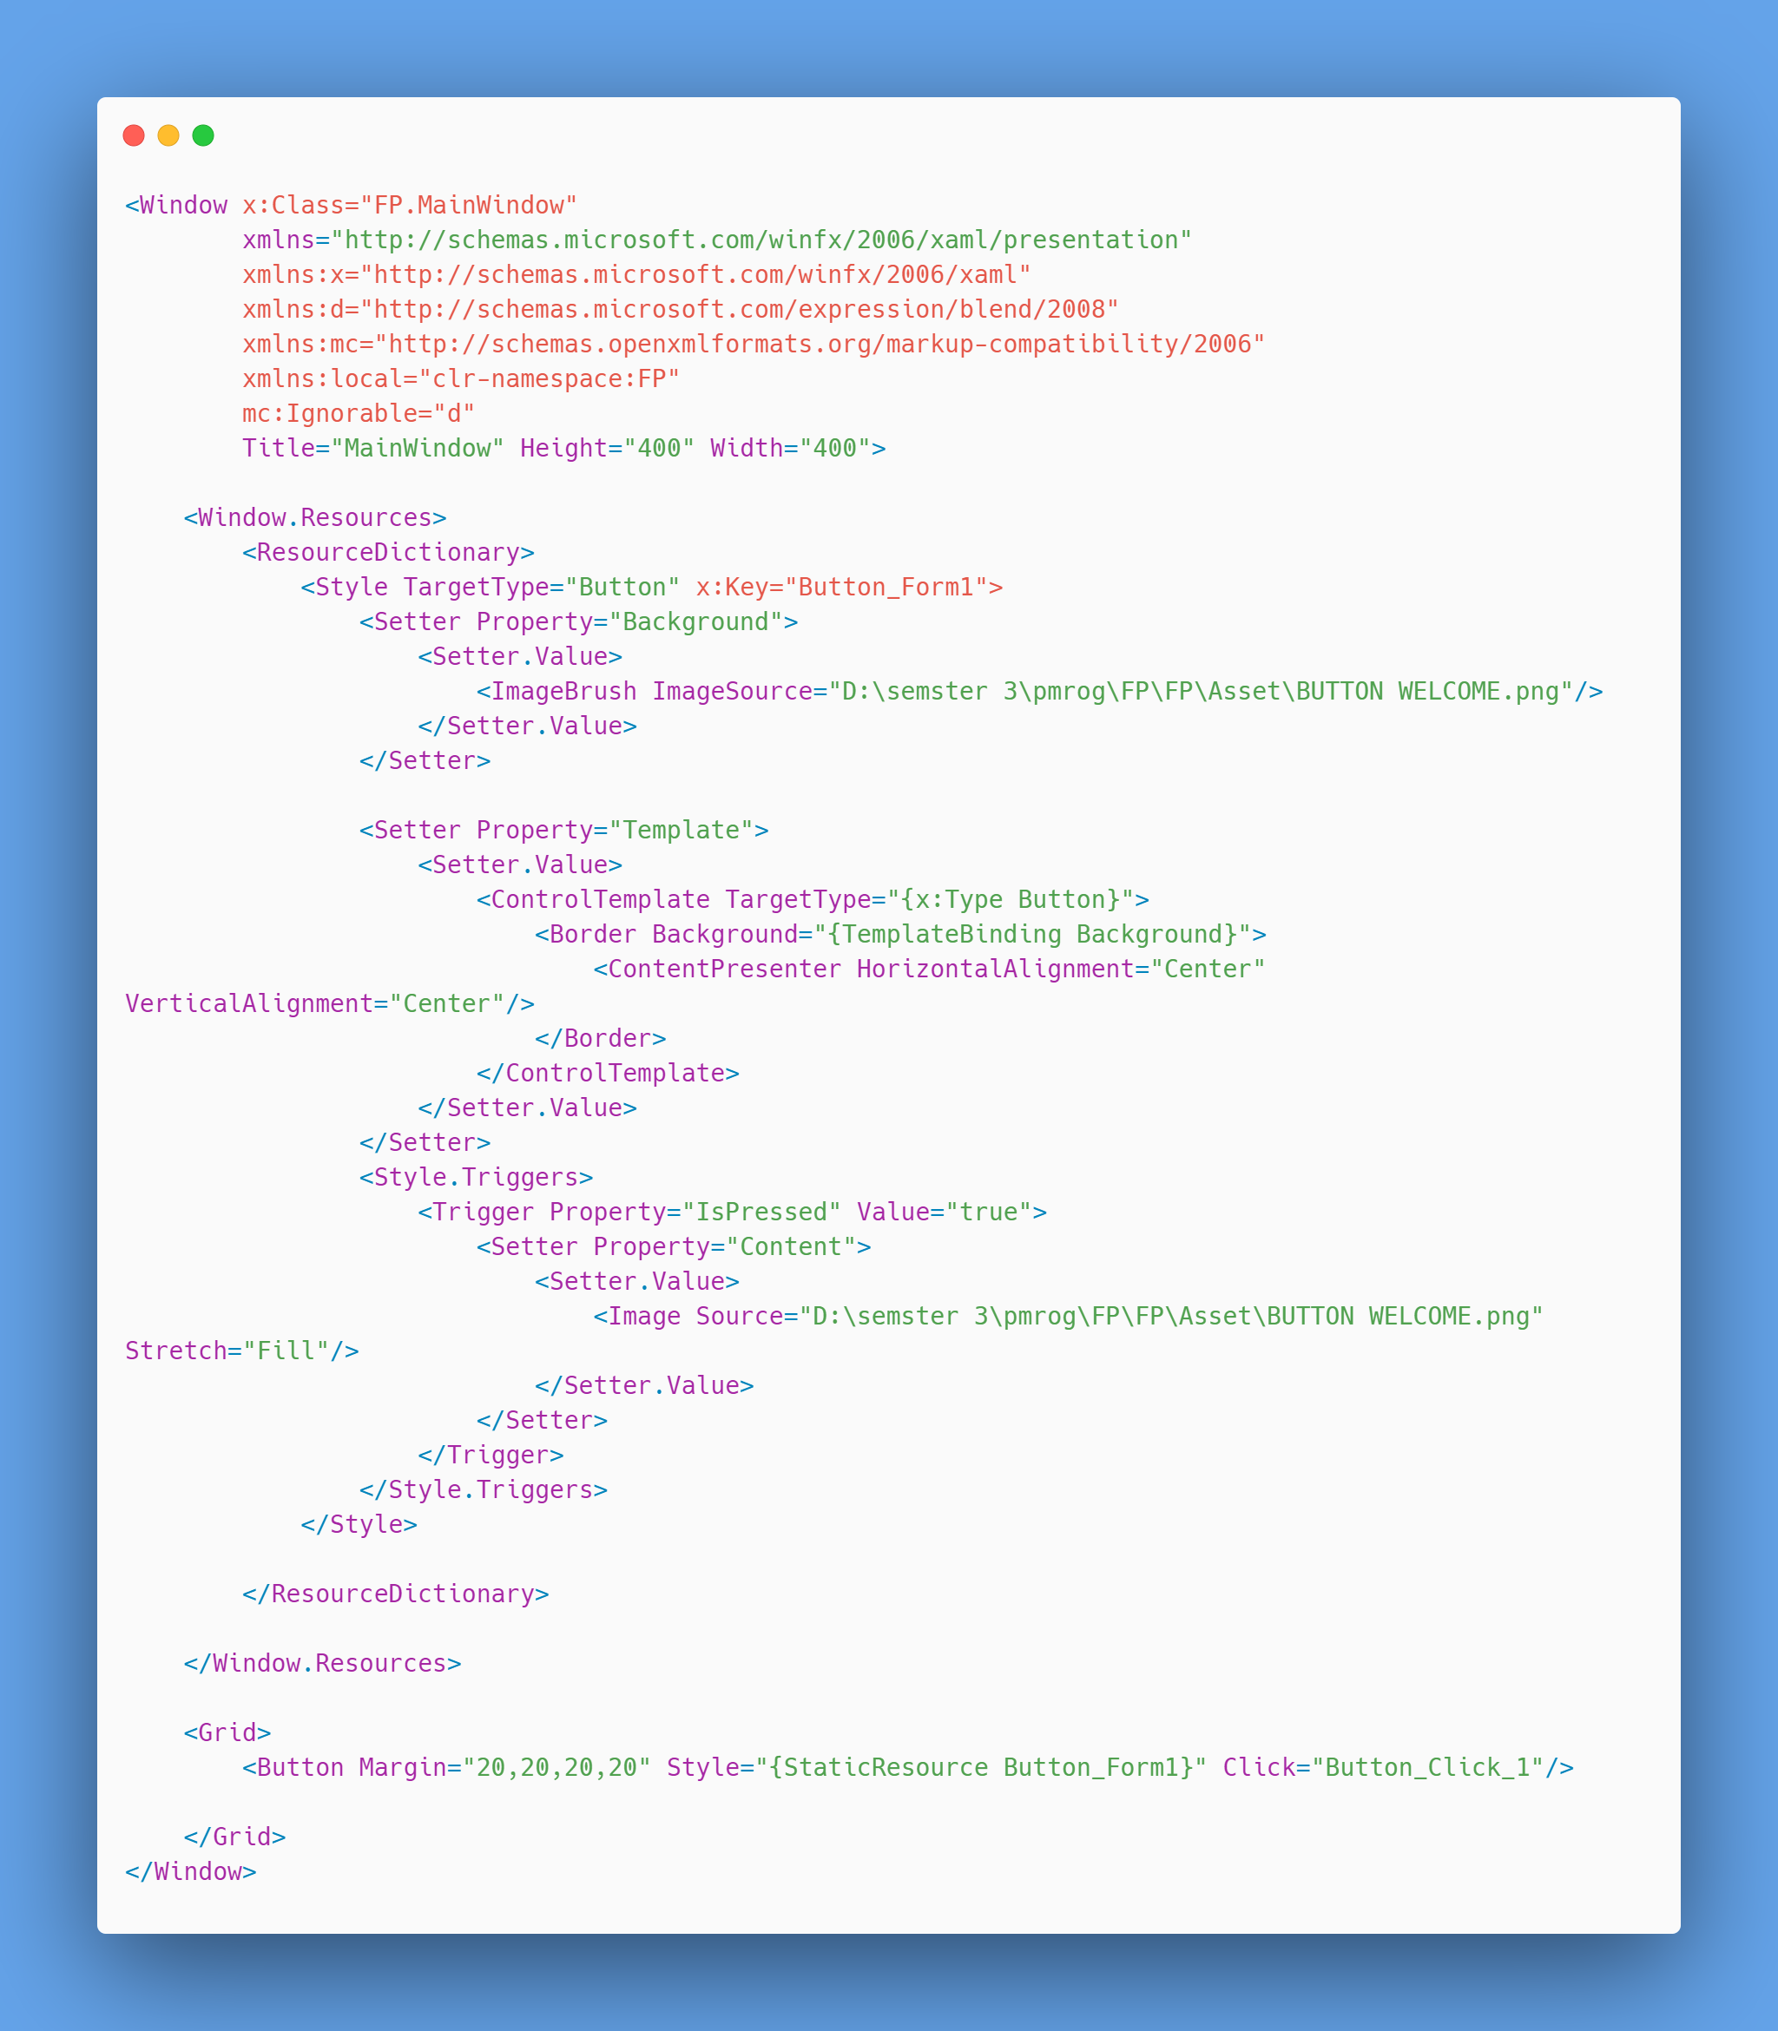

1. Welcome.xaml.cs

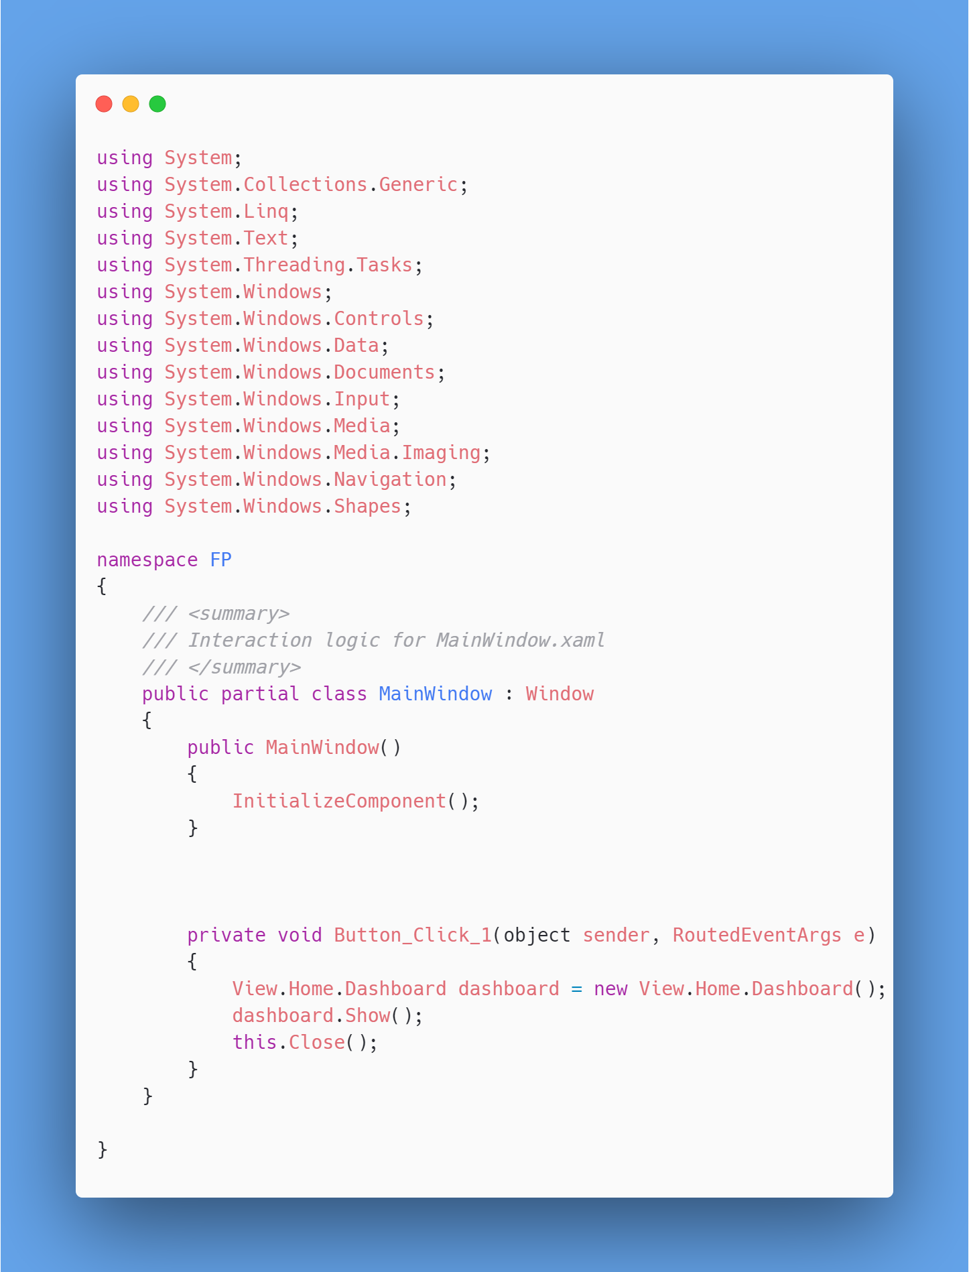

1. **Hasil Run**

